# Project: Summarizing and Analyzing Research Papers

## Submission Template

**Learner Name**: [ABHISHEK]

**Learner Email**: [2005abhishekdhiman@gmail.com]

**Topic**: [**Engineering**: Summarize and analyze research on advancements in renewable energy technologies]

**Research Paper:** <https://www.sciencedirect.com/science/article/pii/S259012302300748X#cebib0010>

### Initial Prompt

### initial prompt.jpg

**Description**: "Summarize the key challenges, opportunities, and policy implications discussed in the research paper titled *'A review of hybrid renewable energy systems: Solar and wind-powered solutions: Challenges, opportunities, and policy implications'* published in *Results in Engineering* (2023). Focus on how the integration of solar and wind power within hybrid systems addresses or exacerbates these challenges, the potential for these systems to enhance energy reliability and efficiency, and the necessary policy measures to support their adoption and scalability."

This prompt should guide the summary towards capturing the essence of the research paper's discussion on hybrid renewable energy systems.

**Generated Summary**: "The paper provides a comprehensive review of hybrid renewable energy systems, focusing on the integration of solar and wind power to mitigate challenges like energy intermittency and enhance grid stability. It explores technological advancements such as machine learning algorithms and advanced inverters to optimize these systems. The study highlights the role of policy frameworks, including successful government incentives and regulatory support, in accelerating the adoption of hybrid systems. The conclusion emphasizes that with continued research, investment, and supportive policies, hybrid renewable energy systems can play a crucial role in meeting future sustainable energy demands."

### Iteration 1

### iletration 1.jpg

**Description**: "Analyze the technical and economic challenges associated with hybrid solar and wind energy systems as discussed in the research paper titled *'A review of hybrid renewable energy systems: Solar and wind-powered solutions: Challenges, opportunities, and policy implications'* published in *Results in Engineering* (2023). Focus on the specific challenges related to system integration, variability in energy generation, cost-effectiveness, and infrastructure. Additionally, examine how innovations in energy storage and power management technologies are being developed to overcome these challenges, improving the overall efficiency and feasibility of hybrid renewable energy systems."

This prompt should help guide a detailed analysis of the technical and economic aspects of the hybrid energy systems and the role of emerging technologies in mitigating associated issues.

**Generated Summary**: "The research identifies key technical challenges in hybrid renewable energy systems, such as optimizing the integration of solar and wind power and managing energy storage effectively. Economic challenges include high initial setup costs and long-term maintenance. Innovations like advanced inverters, machine learning for system optimization, and improved energy storage technologies are highlighted as critical solutions. The paper also discusses the need for robust policy support to incentivize these innovations, ensuring that hybrid systems become economically viable and scalable, thus contributing significantly to global energy sustainability."

### Iteration 2

### iletration 2.jpg

**Description:**Discuss the policy implications for the widespread adoption of hybrid renewable energy systems as outlined in the research paper titled *'A review of hybrid renewable energy systems: Solar and wind-powered solutions: Challenges, opportunities, and policy implications'* published in *Results in Engineering* (2023). Emphasize the role of government incentives, regulatory frameworks, and policy measures in promoting the development and deployment of these systems. Analyze how these policies can address the challenges of integration, encourage investment, and support long-term sustainability of hybrid renewable energy solutions."

This prompt will guide the discussion towards the critical role of policies and regulations in facilitating the growth and effectiveness of hybrid renewable energy systems.

**Generated Summary**: "The paper emphasizes the critical role of policy in promoting hybrid renewable energy systems. It showcases case studies where government incentives, public-private partnerships, and favorable regulatory frameworks have significantly accelerated the adoption of these systems. The study argues that without strong policy support, the potential of hybrid systems to meet sustainable energy demands will remain underutilized. The paper concludes that aligning research, investment, and policy efforts is essential for overcoming current challenges and fully leveraging the benefits of hybrid solar and wind energy systems.

### Final Prompt

### final prompt.jpg

**Description:** "Provide a concise overview of the key challenges, opportunities, technological innovations, and policy implications associated with hybrid solar and wind energy systems as discussed in the research paper titled *'A review of hybrid renewable energy systems: Solar and wind-powered solutions: Challenges, opportunities, and policy implications'* published in *Results in Engineering* (2023). Summarize the main barriers to implementation, the potential benefits, the latest advancements in technology, and the necessary policy measures that can support the widespread adoption and success of these systems."

This prompt will guide the creation of a well-rounded summary covering all the crucial aspects of hybrid solar and wind energy systems.

**Generated Summary**: "This review addresses the integration of solar and wind power in hybrid renewable energy systems, focusing on overcoming energy intermittency and enhancing grid stability. Key challenges include system optimization and energy storage, while opportunities lie in technological innovations like advanced inverters and machine learning. The paper highlights the importance of policy frameworks, with successful examples of government incentives driving adoption. The conclusion underscores the potential of hybrid systems to meet future energy needs sustainably, contingent on coordinated research, investment, and policy support."

### Insights and Applications

**Key Insights**: "This review addresses the integration of solar and wind power in hybrid renewable energy systems, focusing on overcoming energy intermittency and enhancing grid stability. Key challenges include system optimization and energy storage, while opportunities lie in technological innovations like advanced inverters and machine learning. The paper highlights the importance of policy frameworks, with successful examples of government incentives driving adoption. The conclusion underscores the potential of hybrid systems to meet future energy needs sustainably, contingent on coordinated research, investment, and policy support."

**Potential Applications**: "Hybrid renewable energy systems can be applied in various contexts, including rural electrification, urban grid stability, and industrial energy supply. In remote areas, these systems can provide reliable power where grid connectivity is limited. In urban settings, integrating hybrid systems with existing grids can reduce congestion and enhance stability by supplying consistent power. Additionally, industries can use hybrid systems to reduce energy costs and carbon footprints by leveraging renewable energy. Governments can apply insights from the review to craft policies that incentivize the deployment of hybrid systems, encouraging public and private investments in sustainable energy infrastructure."

### Evaluation

* **Clarity**: **"The final summary and insights are clear and concise, effectively communicating the main points of the research paper. The information is well-structured, making it easy to understand the challenges, opportunities, and policy implications associated with hybrid renewable energy systems."**
* **Accuracy**: "The summaries and insights accurately reflect the content of the research paper, capturing the key challenges, technological advancements, and the critical role of policy in promoting hybrid renewable energy systems."
* **Relevance**: "The insights and applications are highly relevant to current energy challenges, particularly in the context of transitioning to sustainable energy sources. The discussion on policy implications and technological innovations is particularly pertinent for stakeholders involved in energy planning and policy-making."

### Reflection: "Working through this analysis provided a deeper understanding of the complexities involved in summarizing technical research while maintaining clarity and accuracy. The iterative approach was particularly valuable in refining the summaries, ensuring that each iteration captured more precise details and insights from the research paper. One of the challenges faced was condensing the extensive information from the paper into the word-limited summaries. This required careful selection of the most critical points and a focus on the broader implications of the research rather than getting bogged down in technical details. The insights gained from this exercise highlight the importance of policy support and technological innovation in the adoption of hybrid renewable energy systems, emphasizing their potential role in global energy sustainability. This reflection has reinforced the value of concise, clear communication in academic and professional settings, particularly when dealing with complex, multidisciplinary topics like renewable energy systems."

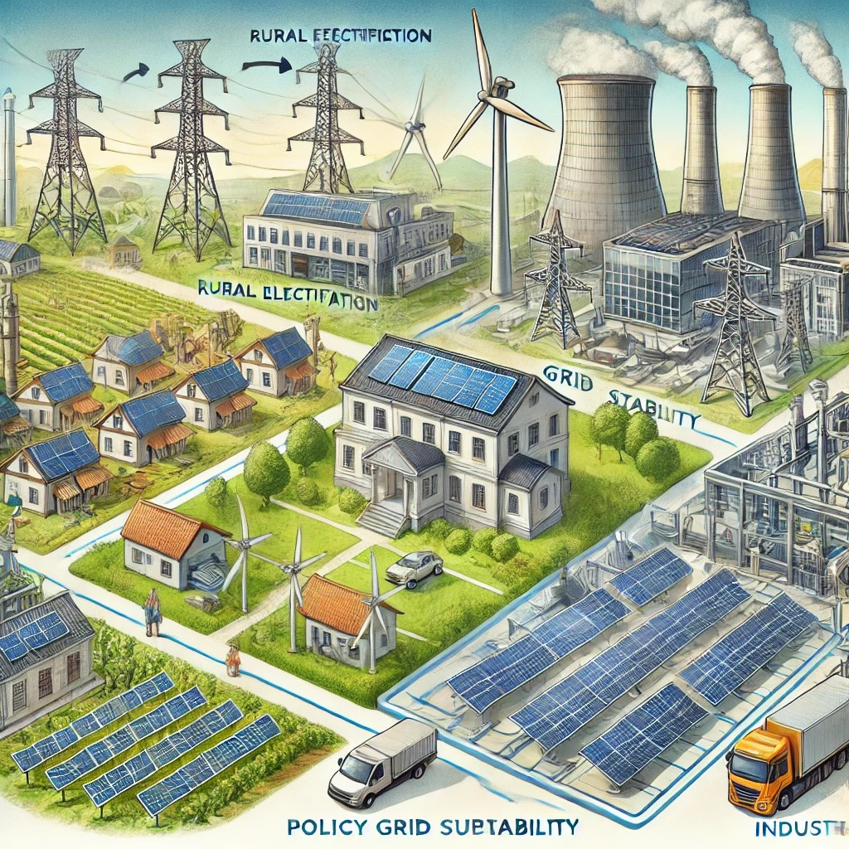

**Image Description:**

This image illustrates the diverse applications of hybrid renewable energy systems, combining solar and wind power. It is divided into three main scenarios:

* **Rural Electrification:**

The image shows a small village powered by solar panels and a wind turbine. This setting demonstrates how hybrid renewable energy systems can provide reliable electricity in remote areas where grid connectivity is limited.

* **Urban Grid Stability:**

- In the urban scene, the hybrid system is integrated with the city’s power grid. This integration helps reduce grid congestion and enhances stability by ensuring a consistent power supply, even during peak demand times.

* **Industrial Energy Supply:**

- The industrial part of the image features a factory using both solar and wind power to reduce its energy costs and carbon footprint. This illustrates how industries can adopt hybrid systems to achieve energy efficiency and sustainability.

In the background, a subtle representation of a governmental building signifies the role of policy support in driving the adoption of these systems. This image encapsulates the potential of hybrid renewable energy systems to meet diverse energy needs across different contexts.